3.1 Defining the Derivative Worksheet

- Find if .

You will have to multiple out unless you can utilize the Binomial Theorem.

- Consider the function .
- Find an equation that will tell you slope of any tangent line on the graph of .

This means that we are looking for the derivative.

- Construct the equation of a line that is tangent to at the point where .

To construct the tangent line we need the point on f where the tangent line is being constructed.
Point:
Slope:

Tangent Line:
- Find the derivative of .

- Find an equation of the tangent line to the curve at the given point.
- ,

We have
Point:
Slope:
Therefore, the equation of the tangent line is

- ,

We have
Point:
Slope:
Therefore, the equation of the tangent line is
- ,

We have
Point:
Slope:
Therefore, the equation of the tangent line is

- ,

We have
Point:
Slope:
Therefore, the equation of the tangent line is

- For the function whose graph is shown below, arrange the following numbers in increasing order.
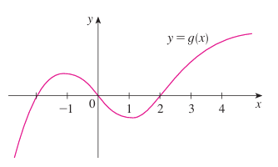

Since each derivative here represents the slope of a tangent line on the graph, we can draw the tangent lines at each point and rank them in order of smallest to largest slope.

Based on the picture we see that we get the following order.
- The displacement (in meters) of a particle moving in a straight line is given by the equation , where t is measured in seconds. Find the velocity of the particle at times:

- The displacement (in meters) of a particle moving in a straight line is given by , where t is measured in seconds.
- Find the average velocity of the particle over each time interval:

- Find the instantaneous velocity when .

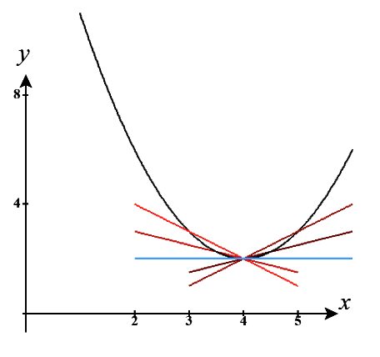
- Sketch a picture of the function s and draw the secant lines whose slopes are the average velocities in part (a) and the tangent line whose slope is the instantaneous velocity in part (b).

The red and brown lines are the secant lines.

The blue line is the tangent line.

- A warm can of soda is placed in a cold refrigerator. Sketch the graph of the temperature of the soda as a function of time. Is the initial rate of change of the temperature greater or less than the rate of change after an hour?

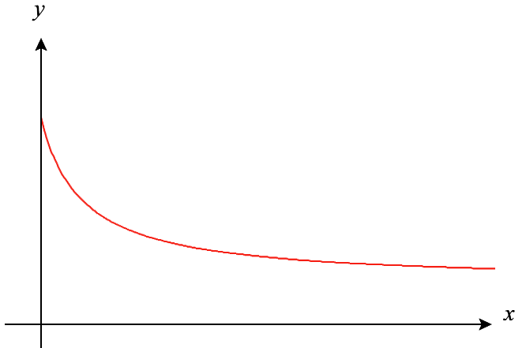
In the following picture we can imagine that the x-axis measures the time the can has been in the refrigerator and the y-axis measures the temperature of the soda.

The initial rate of change is negative.
After an hour the rate of change is still negative, but closer to 0.

Therefore, the initial rate of change is less than the rate of change after an hour.

- The cost of producing x ounces of gold from a new gold mine is dollars.
- What is the meaning of the derivative ? What are its units?

represents the instantaneous rate of change in the cost of producing x units of gold from the mine. The units would be in dollars per ounce.

- What does the statement mean?

This means that when 800 ounces of gold have been produced from the mine that the cost of production is increasing at a rate of $17/ounce.

- The number of bacteria after t hours in a controlled laboratory experiment is .
- What is the meaning of the derivative ? What are its units?

represents the instantaneous rate of change (growth rate) of the bacteria population after 5 hours.

- Suppose there is an unlimited amount of space and nutrients for the bacteria. Which do you think is larger, or ? If the supply of nutrients is limited, would that affect your conclusion? Explain.

Based on how population scaling works (exponential growth) we would expect that . If there were limited nutrients or space then it is possible that the growth rate at may already have reached a maximum and therefore .

- Each of the following limits represents the derivative of some function f at some number a. State the function f and value of a in each case.

Here we have that and .

Here we have that and .

Note that we are using the alternative definition of the derivative here: .
Here we have that and .

Here we have that and .

Note that we are using the alternative definition of the derivative here: .
Here we have that and .

